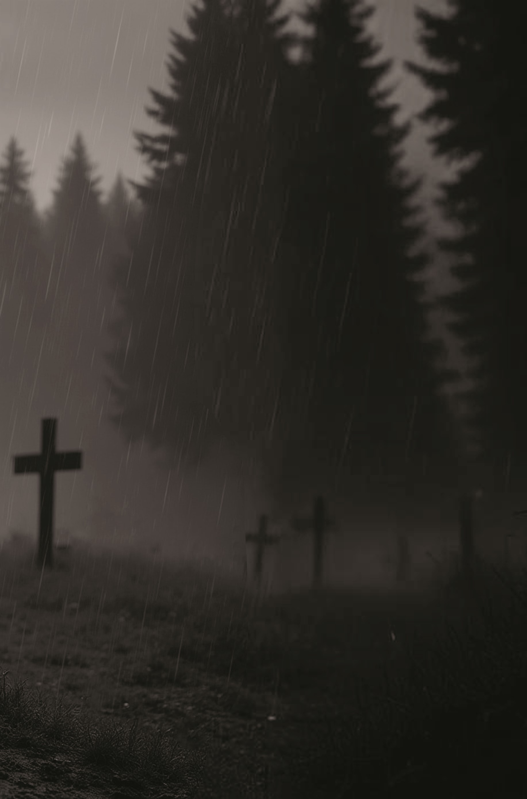
CHAPTER ONE
Present Day, October 31 - All Hallows’ Eve
A mile from the nearest road and obscured by the branches of ancient hardwoods, an old, abandoned church crouches in the forest, awaiting the arrival of the Neola, West Virginia, witches’ coven. Stripped of all references to Christianity, its original white paint having peeled away decades ago, it is the sacred destination for this coven’s Satanic rituals.
Two witches chosen to prepare for tonight’s ritual have arrived early. They work in silence. One—an older, stooped woman with wiry gray hair—pulls her black shawl tighter against her body as late autumn’s cold wind creeps through cracked windows and broken floorboards. She pushes a ladder around the perimeter and climbs it to light oil lanterns suspended from hooks. When that chore is done, except for the lantern in the back-right corner, she plods toward the church’s former pulpit, where she drapes yards of dirty black velvet over the old wooden structure.
The other witch—a younger, rail-thin woman in a long black wool coat—uses a chair to climb up and nail more black velvet to the walls. Moving more easily than the old woman, she finishes quickly.
She then locates a long box in the old choir section and carefully lifts out a cloth banner. With the aid of the old woman’s ladder, she attaches the banner to two hooks in the ceiling above the pulpit and carefully unrolls the likeness of the Baphomet, the winged half-human, half-goat with a pentagram on its forehead.
The old witch drapes more black velvet over what was originally the church’s heavy wooden Communion table. Upon the dusty cloth, she places two large black candles in silver holders, an ornate silver chalice, and an old bell with a wooden handle.
A blast of cold air slices through the space as the front door flings open. Both witches look up to see their High Priest, Stephen Morgana, walk in, followed by his assistant, Gordon, a priest of a lower order. A tall man in his seventy-seventh year, the High Priest is an imposing figure with long gray hair pulled tightly into a ponytail, a neatly trimmed gray beard, and a deep, booming voice. “Ah! Everything is in order. Excellent job, ladies,” he says. While his assistant secures the door, the High Priest clasps his large hands together and closes his small, pale gray eyes. “Tonight, Master,” he prays, “Your glory will be writ in blood.” With that, he steps up onto the pulpit and begins his ritual of donning a black robe, then the hood, and finally the gloves. Emblazoned across the front of his robe is a silver pentagram.
The assistant walks to the Communion table, picks up the two black candles, and moves them to the appropriate location. Looking up at the two witches, he mutters under his breath, “Ignorant old bitches.” Turning to the High Priest, he covers his angst with a smile. “I think it would be wise if I went outside and waited for the children to arrive, don’t you agree?”
“Certainly! What a grand idea, Gordon. Just make sure you bring them straight in the moment you hear me ring this,” the priest says, holding up the bell he had been cradling in his hand.
“Wouldn’t want you to miss a single word of this monumental ceremony.”
The assistant nods in response and opens the door but stops as he catches a glimpse of one unlit lantern. “Hey, you, younger woman. That corner lantern isn’t lit.”
“Sir, I’ve tried to light it, but the wick just won’t catch fire. Must be broken,” replies the younger witch.
Nodding, Gordon walks past the crowd waiting outside for permission to enter. He mutters a hello to the members brave enough to speak to him. No longer able to contain a grin, he glances over his shoulder as he makes his way to the large oak tree flanking the parking lot and leans against it. He takes a cigarette from his pocket and lights it. Slowly, he looks around, surveying the area. He shoves the pack back into his shirt pocket and mutters to the forest, “Where are you hiding, Death Angel? I know you’ve been here because I can smell your stench.”
The dry leaves crackle underfoot as the coven members walk up the path, each one dressed in his or her own black hooded ritual cloak. Though many coven members are advanced in years, cars are not allowed as the secrecy of the ritual location is paramount. Even so, they move along quickly, their excitement mounting with each step as they become fully aware of what the evening holds.
While at the forest’s edge, less than one hundred yards from the old church and unseen by human eyes, a single flash of light signals the arrival of an unexpected guest. Materializing behind the cover of a hardwood tree’s thick trunk, thirty-nine-year-old Arella Fletcher adjusts the hood of her black ritual cloak to conceal her long blonde hair and deep green eyes. When she hears a faint popping sound, she steps aside quickly as another flash of light deposits her son Driael onto the forest floor. He stumbles over a moss-covered tree root, scrambling to regain his footing before standing upright, donning a sheepish grin. Arella laughs and holds up a mock scorecard. “Four out of ten for that dismount.”
“I can land just fine when I’m alone,” Driael says. He brushes dirt and debris from his ritual cloak. “I just can’t adjust to traveling with you. It’s like riding a lightning bolt.”
Arella reaches up to pull a twig from her son’s shoulder-length dark brown hair and grins at him.
Suddenly, he grimaces and covers his nose with the sleeve of his cloak. “Damn! What the hell is that smell? Rotting flesh and cat piss?”
Arella nods. “Hell being the operative word.” She points toward the crowd of witches gathering outside the old church. “See that one with the glowworm-green hair? She has two shit demons riding piggyback. And that warlock, the one with the straggly black beard, he’s carrying around three, can’t you see them?” When he shakes his head, she scoffs. “Perhaps if you’d remove those sunglasses.”
Irritation in his voice, Driael retorts, “I typically do see them, but only those associated with my target. And stop hating on the shades. They're part of my superhero costume.” He smiles playfully and opens his cloak, revealing tight black leather pants, a long black duster, and an array of guns and knives strapped to his belt.
“Fashionable.” Arella chuckles and gives him a peek at her leather ensemble beneath her cloak. “Maybe I should get some sunglasses myself. We could be twins.”
“That's just weird, Mom,” Driael says. “But thanks for clarifying the stench. I was beginning to think Rupert pissed on my clothes again.”
“Don’t be ridiculous,” Arella says. “Rupert would never do anything like that. He's like the Mary Poppins of Ragdoll cats—perfect in every way.”
“Well, Mary Poppins was caught in the act yesterday pissing on one of my black tee shirts.”
“By whom, and was it on the floor?”
“Amanda, and yes, on the floor in the bathroom. Why?”
“Had your shirt been inside the laundry hamper where it’s supposed to be, he couldn’t have peed on it. Am I right?”
Driael ignores her question and motions toward the last few witches gathering at the church steps. “Are you ready? The crowd is thinning, so we should be able to slip in unnoticed.”
Arella nods sharply. “When we go through the door, head to the right corner. I extinguished the lamp earlier. We should have a dark area for cover.”
“Of course you did,” Driael says with a warm smile.
Arella smiles, then pulls her hood forward to hide her face as they walk together toward the church. Pausing, she looks up at her son. “Anything to protect you.”
Ushered in by a young witch, the excited coven members crowd the doorway into the makeshift vestibule. Underfoot of the last few coven members, each dressed in his or her ritual garb, Arella and Driael move unnoticed into the church. Now sequestered in their dark corner, they wait.
Witches and warlocks assemble, standing in rows before the High Priest since the old church’s pews disappeared long ago. Illuminated by the black candles, the High Priest begins the ritual by lifting the bell from the altar and ringing it. Then he and the others raise black-handled athames—ceremonial daggers— high above their heads.
“We now invoke the Four Crowned Princes of Hell,” he calls out, his voice like thunder. Turning counterclockwise with the coven, he points his dagger to the east “for Lucifer,” to the north “for Beelzebub,” to the west “for Astaroth,” and to the south “for Azael.”
“And together, we recite the Invocation.” In one voice, the coven joins him, growing louder as they conclude: “In Nomine Dei Nostri Satanas, Luciferi Excelsi. In the Name of Satan, Ruler of the Earth, True God, Almighty and Ineffable, Who hast created man to reflect in Thine own image and likeness, we invite the Forces of Darkness to bestow their power upon us. Open the Gates of Hell to come forth to greet us as your Brothers, Sisters, and friends…”
Arella whispers, “I’m considering sending SJ to a witch training school this summer. Maybe you can go with him and brush up on your apparition skills.”
Driael leans down and whispers back, “Poke fun at me all you want, but it was you and Great-Aunt Ruby who taught me everything magical. As far as S.J., don’t waste your money, my little brother has no magical blood running through his veins.”
“I beg to differ. Not everyone develops their magic early like you did. Many kids wait until well into their teen years.”
“Good to know.” Driael grins. “There may be hope for him after all.” Looking at his watch, he leans in again. “How much longer until the fun begins? I have a date with Samantha and don’t want to be late.”
“Our new receptionist? I’ve told you not to ever get involved with anyone we employ.”
“But she’s hot,” Driael responds with a grin. “I’ll deal with any fallout if there is any.”
“Fine, but don’t say I didn’t warn you. Humans do not understand our kind.”
“Duly noted,” Driael whispers. “So, how much longer?”
“Once the children are outside. But son, don’t underestimate these people. This is a strong coven, evident by the fact that I was summoned to assist. The minute you remove your superhero cover-up, all hell will break loose, literally. They will do whatever is necessary to protect their Priest, so be prepared. Remember, these people may look human, but they are real monsters. Human killers who enjoy it.”
“I’ll be fine.” He smiles and squeezes her hand. Arella smiles in response. “Anyway, I have you to protect me.”
Arella’s smile instantly fades as she glances toward the door. “The children have arrived. Poor little ones. Their fear is paralyzing.”
Driael looks down, noticing a faraway, pained look in her eyes. He gives her a quick shoulder hug. “Pisses me off too.”
Arella turns toward the door, causing the faint sounds of popping and clicking as she magically seals and locks the coven inside. “Not one of these humans or their demonic pieces of shit counterparts are allowed to leave this place, understood?”
“Thought we were only supposed to take the Priest?”
Arella looks up at her son, her eyes beginning to darken. “If we don’t destroy the entire coven, the carnage won’t stop. It would be like leaving Dracula alive to tend to the blood bank.”
Smiling at her response, Driael comments, “Kill them all, then. You know I love a good reaping. If I’m not late picking up Samantha, all is good. I would hate to call her during the screaming to tell her I was running late. She might get suspicious.”
“If it comes down to that, you can always text her,” Arella responds with a grin.
“For the love of Satan,” a rather chubby blonde woman says as she turns toward Driael and Arella. “I’ve heard enough of your gibber-jabber. You, boy, are an ungrateful bastard. And as for you, ‘Miss Big Mouth,’ you’re old enough to know better. Respect your High Priest and shut up!”
Arella leans in, touching Driael’s hand. Quickly, she grabs the woman by the shoulder and squeezes hard, her lips touching the woman’s ear. “Look here, bitch.” She squeezes harder, and the witch’s cloak lapel opens, revealing a name. “Aw, how cute. You embroidered your nickname on your robe—and in pink, too. Well now, Sparkles, or is that Sprinkles? Oh, never mind.” Arella smiles as she continues. “That’s my son you just called a bastard. Either you turn around and shut up, or I will use these.” She holds up her hands and wiggles her fingers, drawing attention to her razor-sharp nails. “I would love nothing more than to gouge out your eyeballs and feed them to the rats. And trust me when I say I would enjoy every minute of it.” She pauses to lick the tips of her fingers, then winks.
Horrified at Arella’s behavior, the woman quickly turns around.
“Driael, you can kill anyone you choose, but that nasty Sparkly Sprinkles, or whatever the hell her name is—that witch is all mine.”
“You got it,” Driael responds.
“…fill us with truth, wisdom and understanding, keep us strong in our faith and service, that we may abide always in Thee, with Praise, Honor and Glory given Thee forever and ever!”
Meanwhile, outside...
Gordon looks back at the old church. Listening to the faint pops and clicks the windows and doors are making, he grins. “Lenny,” he says to the coven member guarding the newly arrived children. “How’s it going, man? Damn! You look a little green.”
“The missus, she was fussing for three hours cause I’m here tonight. I think she must have put something in my food. Terrible upset stomach ever since I ate supper. Been rough, man. Had to shit in the woods three times. No toilet paper either, so I used some leaves. Probably get an asshole rash from it.”
Laughing, Gordon pats him on the back. “Maybe you should have listened to your wife there, buddy. It would have been a little easier on the digestive system and the backside.”
Lenny just grunts as Gordon walks past him toward the forest’s edge. Taking his phone from his back pocket, he speaks, “Call Valerie.” Waiting for her to answer, he pushes along a trail of ants with the toe of his boot, then squats down and catches them on fire with his lighter.
“Valerie, what the hell?” he says when she answers.
“I was in the shower, Gordon. Where did you think I was? You sound stressed. Are you okay?”
“I’m fine,” Gordon says as he stands back up, “but I don’t think that will be the fate of this coven.”
“Why? What’s going on?” Valerie asks as she wraps a large brown towel around herself.
“It’s Arella. She is here with Driael.”
“Driael? That’s an odd name. Who is that?” Valerie asks.
“Don’t you remember that dark-headed kid from the Fletcher reunion? His stepfather is Dr. Bachman. The doc who treated Sabrina that night in the emergency room when she twisted her wrist jumping from the top of the van roof.”
“Now I remember,” Valerie giggles. “That’s the time Sabrina said she wanted to learn to fly, but forgot she didn’t have wings.”
“Yes,” Gordon laughs. “My daughter experiments daily with new ways to give me a heart attack.”
“Sabrina takes after your side of the family, you know that, right? I am ever grateful she finally found her magic and wings. I am sure so is the health insurance company. Now, what is this about that doctor?”
“It’s his stepson that I am talking about. The famed demon hunter. God’s warrior and the demon spawn’s pretty boy,” Gordon says sarcastically. “I was wondering where that demon bitch mother of his was keeping herself. Now I know.”
“Oh, wait. You mean your sister Arella’s son? He is handsome. Did you talk to them?”
“Yes, that’s who I’m talking about, but I didn’t talk to either of them. But I smelled her stench the minute I walked into the church. I know she was there as ‘Death’ always reeks of old rotted flesh.”
“Gross, Gordon. TMI. So, what happened to Mr. Morgana?” Valerie asks.
“Nothing yet, but he will be dead soon,” Gordon says as he unbinds his blond hair from the ponytail, letting it fall to his shoulders. He removes his ritual cloak, balls it up, and tosses it into the brush.
“So, what are you supposed to do now? Wasn’t that your assignment? Won’t your boss be angry?”
Gordon chuckles. “So many questions, but in answer to them all, I don’t care. But that means I’m on my way home. Not dressed yet, are you, sweetheart?”
“Nope, babe, still in my towel. But you haven’t told me what’s going to happen to the children?”
“They’ll be fine. God’s cavalry is here, remember?” Gordon ends the call and slides his phone into his back pocket. Looking toward the old church again, he smiles and murmurs under his breath, “It’s been a long time, little sister. I was wondering where you’d been hiding. It appears I now know exactly where to find you.” Glancing around to ensure no one is looking, he snaps his fingers and opens a crackling, dark-red split in the otherwise quiet forest. He steps into it and disappears.
Back inside the church...
Each member’s anticipation is palpable in the cold, dark space as the coven falls silent again. The High Priest turns to face Baphomet. His voice loud enough to be heard throughout the forest, he exclaims, “We will torment the unbelievers by mutilating their progeny!” The coven cheers until he raises a hand for silence. “But first, we must summon our demons through the power of meditation and...” He holds his knife up and stares at it. “...the power of the athame. Bring them forth, my beloved children of Satan, so that the sacrifice may begin.”
Each member of the coven holds his or her knife high while outside, six children, age four to seven, weep in the cold night as their captors grip them tightly and await an order to take them inside.

VANESSA - WEBSITE IMPLEMENTATION NOTES
This final page is a developer handoff and is not part of the published chapter.
Main navigation | Replace the top navigation tab “Send a Raven” with “Read Chapter One.”
Page destination | The new tab opens a dedicated page containing the Chapter One artwork and the complete chapter text in this document.
Desktop body text | Georgia, 20 px; line-height 1.65; maximum reading width 760 px.
Mobile body text | Georgia, 18 px; line-height 1.6; 20 px left and right padding.
Paragraph spacing | 1.05 em after each paragraph. Do not compress paragraphs into a continuous wall of text.
Text colors | Body #181717; chapter accent #641C1E; warm page background #F8F5EF.
Preserve | Raven’s Hall, Raven’s Vault, the Book of Shadows, prophecy material, character experiences, and the future Aunt Ruby experience.
Contact feature | The underlying Send a Raven contact experience may remain elsewhere on the site; only its top-navigation position is changing.

